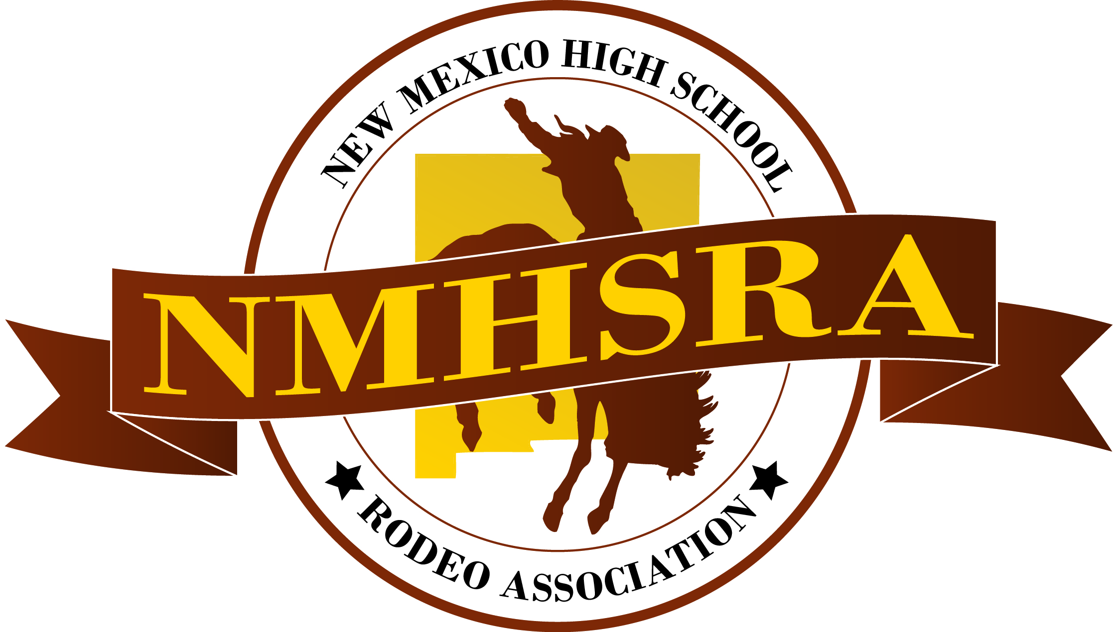  New mexico high school rodeo association officer application  2023-2024 | Guidelines  By completing this application, you will be in consideration for an office within the NMHSRA. If selected you will be a leader of the NMHSRA and it will be your duty to represent our chapter to the highest quality. You will be expected to work hard and complete all tasks with the upmost diligence. It is an honor and a privilege to serve NMHSRA. Please complete the entire application.  Jamey Shiver  NMHSRA President

General Information:
- Full Name:________________________________________________
- Home Phone:______________________________________________
- Cell Phone:________________________________________________
- Address:__________________________________________________
- City:_____________________________________________________
- State:____________________ Zip:____________________________
- Birthday__________________ Age:___________________________
- Parents/Guardians:__________________________________________
- Years in NMHSRA:______________________________________________
- What class will you be in for the 2023-2024 School Year?
  - Sophomore____
  - Junior____
  - Senior____
- Please select all offices that you are interested in serving. (Only Seniors can run as President and Vice President)
  - President_____
  - Vice President_______
  - Secretary______
Questions for Officer Candidates:
- Have you read the responsibilities of being a NMHSRA Officer and understand the duties that you are expected to fulfill?
  - Yes. b. No.
- Are you willing to attend the NHSRA winter meeting?
  - Yes. b. No.
- Are you prepared to act and perform duties that will enhance/improve not only yourself, but also NMHSRA?
  - Yes. b. No.
- Will you conduct yourself personally to high ethical and moral standards?
  - Yes. b. No.
- Have you read and do you understand the Officer Discipline Policy?
  - Yes. b. No.
- If elected will you agree to and sign the Officer Commitment Form?
  - Yes. b. No.
- Do you hold a job? If the answer is yes where do you work?
  - Yes. b. No.
- If given prior notice will you be able to attend all officer meetings and activities?
  - Yes. b. No.
- List three goals that you have for the NMHSRA.

- Describe why you would like to be a NMHSRA Officer. Describe your strengths and tell how the NMHSRA could benefit from you being an officer.

- Why should you be selected as an officer for NMHSRA?

Activities:
What (top 5) NMHSRA activities have you participated in above the chapter level (section, district, state, and national)? Examples: contests or C.D.E.s, conferences, conventions, county fair, etc.
Activity | Year(s)

What NMHSRA activities have you participated in at the chapter level?
Activity | Year(s)
List any offices you have held in NMHSRA or any other organization and briefly outline your responsibility.
Office | Year(s)

What other clubs/organizations are you involved in?
Club/Organization | Year(s)

What athletics are you involved in?
Sport | Year(s)
Letter of Recommendation:
You will need to obtain at least one letter of recommendation from teachers, coaches, or other support staff members recommending you for a position as a NMHSRA Officer. You may include two letters when you submit the letters. Submit the letters of recommendation when you submit the Application.

Agreement:

I _____________________ (student name) understand that serving as an officer in the NMHSRA is a privilege and not a right.

- I agree to complete the duties of the office to which I am elected to the fullest of my abilities.

- I will work with my fellow officers to develop activities and projects to better NMHSRA.

- I agree that if I am elected as an officer of the NMHSRA that I will sign and follow the Officer Commitment Form.

Student Signature _____________________ Date __________

I fully understand the commitment and responsibility which my son/daughter is undertaking as a NMHSRA Officer and agree to support the efforts and decisions of the directors to the officer team in the event my son/daughter fails to meet the commitment he/she is hereby agreeing to undertake.

Parent/Guardian Signature ______________________ Date __________

All of the information contained in this application is complete and accurate to the best of my knowledge.

President’s Signature: ______________________ Date __________

